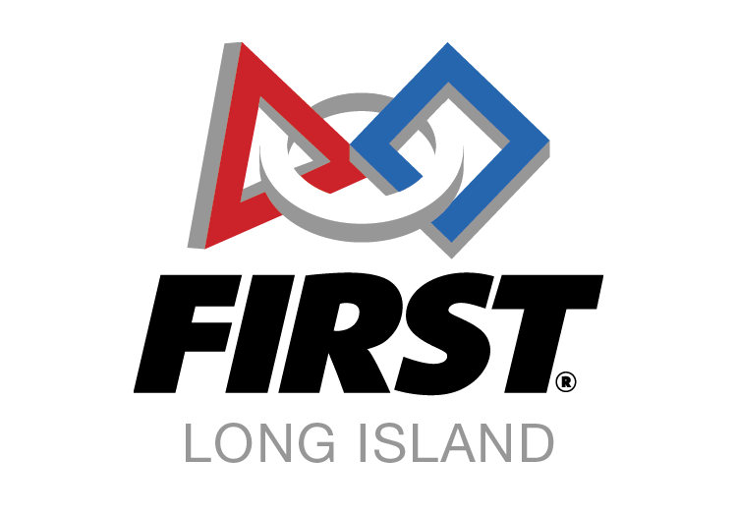
Presented by School-Business Partnerships of Long Island, Inc.

Invoice

Registration Fee for FIRST LEGO League Jr. Team(s) to participate in one of the four SBPLI FIRST LEGO League Jr. Expos at:

William Floyd High School in Mastic Beach - Saturday, January 11, 2020

Mineola High School in Garden City Park - Saturday, March 7, 2020 (morning or afternoon)

Longwood High School - Sunday, March 8, 2020

Please remit $55.00 per team.

You can pay via PayPal at http://firstlongisland.org/payments

or

You can pay with a check payable to SBPLI, Inc. and send it to:

SBPLI, Inc.
c/o Janet Anderson
155 Hidden Pond Circle
Smithtown, N.Y. 11787

Be sure to include your team number on the check or in PayPal, and on all correspondence.

Thank You.

Robert & Eileen Kaler
Program Co-Directors
FIRST LEGO League Jr.

School-Business Partnerships of Long Island, Inc.
P.O. Box 101, Kings Park, New York 11754
(631) 627-8400 SBPLI.org or FIRSTLongIsland.org

